**Video game short-list**

1. Tetris
2. Apocalypse
3. Goat Float
4. Tetris:

A one or two player game where the player turns various shaped blocks which constantly drop from the top of the play area, fall at a given pace (based on difficulty level), and then lock in to place when they hit the bottom of the play area, or make contact with another block already in position. The user can eliminate blocks if they can make them be continuously adjacent from the left side to the right, all on a single level. Points are awarded for blocks dropped, and for block elimination. The two player version would be a sequential game where one player would go first, then the other would go second. The scores would then be compared between the two.

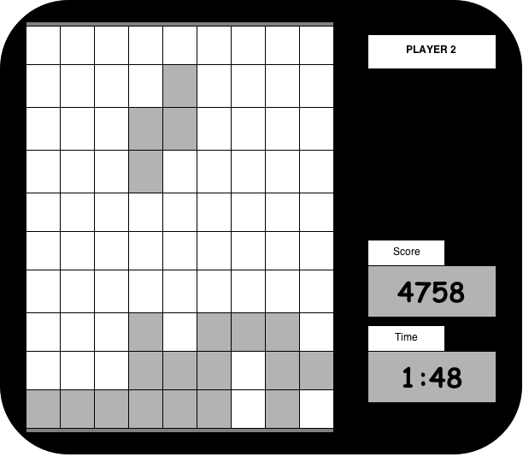

1. Apocalypse:

A game where you are some form of prominent character who is trying to survive a zombie apocalypse. Simple left to right movement and use of a gun to fire at approaching zombies would be the mechanics behind beating a level. The game will make the character move forwards at a given rate (possibly based on difficulty) and while moving different waves of zombies will appear. Once the end of the level is reached by the player, they can advance to another. A two player version could include two characters on the screen, where one player uses arrow keys and the other uses ‘a’ and ‘d’ to move their characters. Shooting could be the ‘w’ and up arrow key.

<insert image>

1. Goat Float:

An adaptation of the game “flappy bird”. The user uses only the space button. The space button will act as a “float upwards” command, whereas not using it will cause the goat to float downwards. Randomly generated walls protruding from the top and bottom will appear as the goat will be moving at a constant rate from left to right. Points are awarded based on distance travelled. The two player version would be a sequential system where one player would go, then the other would follow. Then, their scores would be compared to determine a winner.

<insert image>